

The Ultimate MSP
Go-To-Market Plan Template

This Resource Is Provided By:
Robin Robins, CEO
www.TheMarketingTeam.com

Copyright:
This material is copyrighted by TMT, LLC. ALL RIGHTS ARE RESERVED. No part of this book may be reproduced, shared or transmitted in ANY form, or by any means, electronically, verbally or mechanically, including photocopying and recording, or by any informational storage or retrieval system, without express written permission from the publisher.

Published By:
TMT, LLC
5301 Maryland Way, Suite 300
Brentwood, TN 37027
USA

Disclaimer and Legal Notices:
While all attempts have been made to verify the information provided in this book and accompanying presentation, neither the Author nor the Publisher assumes any responsibility for errors, inaccuracies or omissions. Before implementing the strategies outlined within, you must be aware of the various laws governing business transactions, marketing or other business practices in your particular geographic location as some of the suggestions made in this book and seminar program may have inadvertently introduced practices deemed unlawful in certain states, municipalities and countries. This book is not intended for use as a source of legal or accounting advice. In all cases, you should consult the services of a professional, licensed attorney in all matters pertaining to the operation, delivery and marketing of your business and services.

[Your Company Logo]

[Your Company Name]

MARKETING PLAN
[Month] [Year]

[Your Name]
[Your Title]
[Your Company Name]
[Your Address]
Phone: [ ]
E-mail: [ ]
URL: [ ]

CONFIDENTIAL

The 4 Components To A
Successful Marketing Plan
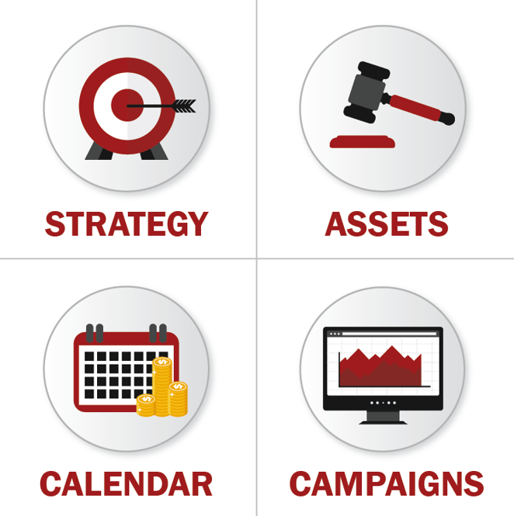

IMPORTANT: This document should be used in conjunction with the 12-Month Marketing Plan worksheet to plan your calendar, campaigns and budget.

Strategy

Goals And Objectives

Company Key Initiatives
In order of importance, what are the company’s top 3 to 5 key initiatives (goals) for this year?
#1:
#2:
#3:
#4:
#5:

New Client Acquisition Goals
Item: | Best-In-Class  Metrics To Goal For | Previous Year’s Number | This Year’s  Goal | % Of Change
Revenue: | 12%+ YoY | $X | $X | X%
EBITDA: | 18%+ | X% | X% | X%
New Clients Acquired | 1 MRR Client Per  Location Per Month | X | X | X%
Average MRR | $3,000+ MRR | $X | $X | X%
Average TCV  (Total Contract Value) | MRR + Projects  Typically 3-Year Deals | $X | $X | X%
Close Rate From SQLs | 35% Close Avg.  65% Close BIC | X% | X% | X%
SQLs Needed  (Also Called FTAs) | 65%+ Of MQLs Should Convert To FTAs | X | X | X%
MQLs Needed | 50% To 60% Of All Leads Should Be MQLs | X | X | X%
Raw Leads Needed | Sufficient To  Fill The Pipeline | X | X | X%

Sales And Marketing Budget

Best-In-Class MSPs are spending a total of 11% on sales and marketing combined. This includes all media, printing and software (CRM, dialer, LinkedIn, etc.) as well as salaries for 1099 contractors and dedicated sales and marketing people on staff.

Please see our 12-Month Marketing Plan spreadsheet to calculate your budget and then cut and paste it into the space below. Below is an example of a budget.

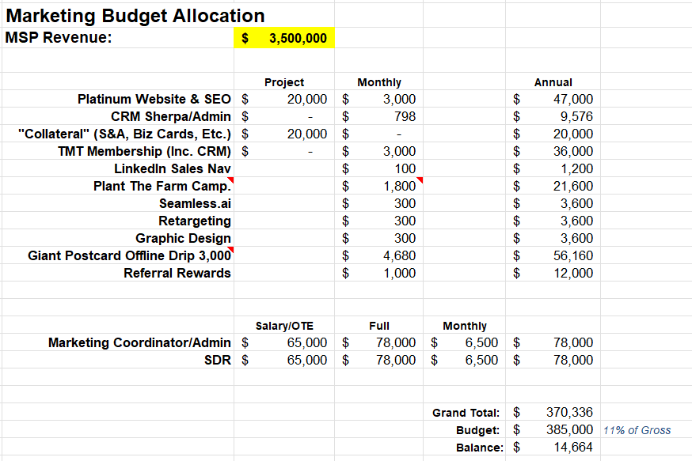

Target Market

A good place to start when selecting a target market is to identify the common characteristics of your BEST clients. Use the list below to define your target market EITHER based on your current best clients OR by defining a target market you WANT to target. This is also the criteria you should use for determining what a Marketing Qualified Lead (MQL) is.

Geography:
Country, state, city, mile radius from zip code, etc.

Industry & SIC:
Broad (medical, nonprofit, construction, manufacturing)

Specialization:
Example: Medical (broad) to specialization (chiropractors, dentists, hospitals)
Key Metrics:
Number of employees, revenue, locations, etc.

Decision Maker:
Who is the key person you want to get a meeting with? What titles do they go by?

Influencer:
Who else in the account influences the decision?

Other Demographics:
Type of entity
Technology, LOB applications
Compliance requirements
Years in business
Number of IT staff

Target Market

Here are some additional demographics to consider when defining your “sweet spot” target market. These may or may not be relevant to someone being a high-value, high-probability prospect for you.
- Age
- PE, venture capital backed
- Type of employees (mobile workforce, office-based, 1099, part-time, etc.)
- Length of time in business (start-ups vs. older corporations)
- Gender, ethnicity, religion
- Regulatory compliance (HIPAA, PCI, etc.)
- Problem specific (high-risk, complex cyber security environment, mobile workforce)
- Specific project (e.g., they need to migrate on-premises Exchange server to cloud)

Keywords:
What types of keywords might your target market search on when looking for IT services and support? Think LOB applications, trends or legal compliance.

Associations:
What associations, peer groups and networking events might your target market attend or participate in?

Influencers, JVs:
What person or entity has influence over your target market and is not a competitor to you?

Aspirational Identity:
What does your prospect aspire to become? How do they want to be thought of by others?

Target Market Analysis

To the best of your ability, outline the TAM, SAM and SOM.

Total Addressable Market (TAM):
What is the total number of potential clients (number) in your target market, and how much revenue would you generate if you achieved 100% market share (no competition)?

Serviceable Obtainable Market (SOM):
What is the total number of potential clients (number) you can reasonably acquire as a paying client, and what does that represent in total revenue?

Target Market Problems And Wants

What’s The Problem(s) They Need To Solve?
Be sure to articulate it as THEY would say it, not how you would.
How Does Having
That Problem Make Them Feel?

List the EMOTIONS (frustrated, angry, anxious, annoyed, etc.).
What Are The Deeper Consequences Of The Above Problem(s)?

Note: They might not realize all the consequences.
Why Is The Problem An Epic Injustice?
Use words like “shouldn’t” and “ought” and “deserve.” Example: Getting good IT support from competent techs shouldn’t be this difficult.
What RESULTS Do They Want To Attain?
Think in terms of the end result they want to achieve in their business, career or the “project” you are helping them with.
What Do They Want From Their IT Provider?

Articulate what they want in the way they would articulate it from their IT company. Examples include responsiveness, price, location, results and guarantees, convenience, specialization, etc.
What Do You Need To Add Or Improve?

With a focus on the previous 2 questions, is there anything you need to change, add or improve about your services to better deliver what your client wants in RESULTS or in their next IT provider?

Success And Failure:

What Positive Results Will They Achieve By Hiring You?
Articulate the benefits and success as THEY would articulate it, not how you see it.
What Negative Consequence Will Happen If They Don’t Hire You?

Outline all the consequences of them not buying at all or from a competitor.
Competitive Analysis

Direct Competition:
Who are your 5 biggest direct competitors, and where do you have a strength or advantage over them (Our strengths) and where do you fall short (Our weaknesses)?

<Competitor 1> | Our strengths:  Our weaknesses:
<Competitor 2> | Our strengths:  Our weaknesses:
<Competitor 3> | Our strengths:  Our weaknesses:
<Competitor 4> | Our strengths:  Our weaknesses:
<Competitor 5> | Our strengths:  Our weaknesses:
Indirect Competition:
What are the top 3 options your clients have that indirectly compete with you? This may include software vendors providing some level of help desk and IT support but not full managed services, hiring someone in-house vs. outsourcing, etc.

<Competitor 1> | Our strengths:  Our weaknesses:
<Competitor 2> | Our strengths:  Our weaknesses:
<Competitor 3> | Our strengths:  Our weaknesses:

Why You?
Unique Selling Proposition

What’s Your Unique Approach (USP) To Solving
The Problem Or Delivering The Result(s) They Want?

A USP, or unique selling proposition, answers the question “Why should I do business with you over all other options available to me?”

For a USP to work, it must:

- Be unique to you
- Have meaningful specifics
- Have a strong appeal
- Be defensible before they buy

A USP must be developed; it’s your competitive advantage in the marketplace so you avoid getting shopped on price.

- What do you do that others don’t?
- Make it sound like a new idea
- Make it easy to understand
- Keep it brief

Sales And Marketing Team

Who Will Do The Work?
This section is designed to help you think through all the roles you will need in your sales and marketing department. To the right, put the name of the full-time person OR the date you need to hire them. If you are outsourcing this role, then put the name of the vendor. In a smaller MSP, the owner might own the CMO role. As your company grows, you will continue to add to the team as needed.
Also note that some of the roles may be held by one person. For example, your Marketing Manager might also be responsible for organic posts on social media and running paid ads; but be careful not to put too many roles on one person. Someone who is an “A” player as a web designer may be a “C” player on SEO.

Marketing Leadership
CMO (Chief Marketing Officer) Or Marketing Director  Primary job is to create and manage the strategic go-to-market strategy, budget and team to achieve the company’s overall growth goals. | Full-Time:  Outsource:
Marketing Director  Primary job is to oversee the tactical implementation of the CMO’s strategy, managing campaign budgets, calendars, assets, etc. | Full-Time:  Outsource:
Marketing Manager Or Coordinator  Primary job is the tactical coordination of the vendors and specialists creating and executing the campaigns directed by the CMO or Marketing Director. | Hire:  Outsource:
Marketing Administrator  Primary job is to complete administrative tasks for the sales and marketing team, such as list cleaning, mailing, proofreading, etc. | Full-Time:  Outsource:
Digital Marketing
Web Design  Primary job is the design of your website(s) and landing pages. They will take direction from your Marketing Lead on design, function and copy. | Full-Time:  Outsource:
Web Development  Primary job is the more technical maintenance of your site’s stability, security and more advanced functionality. | Hire:  Outsource:
SEO  Primary job is to research, develop and work with the web designer to implement an SEO strategy to drive qualified traffic to the website. | Full-Time:  Outsource:
Paid Digital Marketing  Primary job is to create and run ads on various social media platforms and search engines to drive qualified leads at an acceptable cost per lead. Note that one person might not be well-versed in all platforms and media. Someone who specializes in Google PPC might not be an expert on Facebook ads. | Full-Time:  Outsource:
Social Media Manager  Primary job is to create and post organic content on key social media websites to drive engagement, followers, etc. | Full-Time:  Outsource:

Marketing Team, Continued…

Marketing Functions
Graphic Design  Primary job is to lay out and brand various marketing pieces such as direct mail, Shock-And-Awe materials, business cards, van wraps, logo gifts, etc. | Full-Time:  Outsource:
CRM/Marketing Automation/Tech Lead  Primary job is to build the systems and manage the tools you use for automating your marketing, including your CRM, dialer, marketing funnel forms and automation, etc. | Full-Time:  Outsource:
Copywriter  Primary job is to write the marketing copy that goes on all marketing communications, including your websites, paid ads, etc. | Hire:  Outsource:
Multimedia Editor  Primary job is to create videos for various social media posts, ads and marketing funnels. | Full-Time:  Outsource:
List Out Any Additional Hires:
Sales Department
Sales Manager  Primary job is to grow the sales department in quantity (reps) and quality (performance). They typically don’t have a personal quota and are compensated for hitting company sales targets. | Full-Time:  Outsource:
Outside Sales (Hunter)  Primary job is to prospect, qualify and close new clients. | Full-Time:  Outsource:
Account Manager (Farmer)  Primary job is to conduct QBRs with current clients to ensure their satisfaction while also growing sales for that account and securing referrals. | Full-Time:  Outsource:
SDR (Sales Development Rep)  Primary job is to find and develop opportunities (appointments) for the outside sales reps. They will handle inbound leads as well as conduct cold prospecting campaigns to find opportunities. | Full-Time:  Outsource:
List Out Any Additional Hires:

Assets

Celebrity, Authority And Trust
C.A.T.

What Trust- And Authority-Building Marketing Assets Will You Build And Use?

You don’t have to use ALL of these strategies, but you do need to start assembling a number of trust- and authority-building assets to use.

- Specialization, industry vertical
- Specialization, niche
- Specialization, problem
- Local business, years in business
- An abundance of online reviews
- An abundance of testimonials
- Compelling case studies
- Awards, “Trust Seals”
- Certifications
- Guarantee(s), warranty
- X Ways You’re Better comparison
- Price, high or low
- Celebrity clients
- Celebrity endorsement
- Publishing reports
- eBook or book
- Media appearances
- Origin story
- Public speaking, webinars
- Podcast, YouTube channel
- Diagnostic analysis/sales process
- Documentary
- Large-scale social media following

Lead Generation Offers
(E.D.R. Strategy)

What Information (Top Of The Funnel) Would Your Ideal Prospect Like To Have That Strategically Facilitates Sales?
- IDEA: A buyer’s guide on what to look for and what “good” is for what you’re selling.
- IDEA: A checklist, webinar, research report, guide, etc., on how to solve a big problem they want to solve.
- IDEA: Make a list of common questions you get and answer them.
- It must have a compelling title so that your prospect wants to consume it (read, watch, listen, download).
- It should establish your authority and showcase your expertise.
- It should provide useful information that helps facilitate sales.

What Type Of Consultation, Service Or Assessment (Middle Of The Funnel) Would Your Ideal Prospect Like To Have?
- It must transcend immediate need (a quote is only useful if I have an immediate need).
- It must overcome the “We’re fine” objection.
- It must have high perceived value.
- It must prove the need for your services and recommendations.
- It must develop urgency to buy.
- It must naturally lead to selling your services.
Examples:
- Cybersecurity Risk Assessment
- Dark Web Scan

Lead Generation Offers
(E.D.R. Strategy)

Using 3 Steps, Outline What Will Happen On The Consultation.
People won’t move forward into the unknown. Using 3 steps, outline what happens when they sign up for a consultation. For example:
- Step 1: Schedule Your Risk Assessment Consultation
- Step 2: We Deliver A Report Of Finding And Action Plan
- Step 3: We Help You Implement The Plan And Gain Peace Of Mind

Marketing Assets

Strategy:
While you’ll create a more detailed calendar, budget and campaign plan in the 12-Month Marketing Plan worksheet, in this section, simply conduct a quick audit of the most important assets you have.

Website | What primary URLs will you focus on building search authority around? For each of those:  - Do you have a clear target client profile for each URL?  - Does the site’s copy compel the right prospects to engage?  - Do you have a keyword plan and strategy?  - Do you have E.D.R. offers (top of the funnel and middle of the funnel) that work?  - Do you have a tracking system to determine the true effectiveness of the site?  - Do you have a person/team dedicated to making this asset productive?  Which of the following will you put the most effort and budget behind to drive site traffic?  - SEO  - Pay-per-click search  - Paid ads on social media  - Paid ads on strategic ezines, websites  - Offline marketing (direct mail, SDR prospecting, radio ads, etc.)
Social Media, Directories, Google Business Profile, etc. | What platforms will you focus on? Note: These should be chosen based on the platforms most used by your target market.  - Who on your team owns the management of these platforms?  - Is your profile complete?  - Does it convey your USP?  - Does it have offers (where appropriate)?  - Are you posting with sufficient frequency to drive engagement?  - Are you monitoring it daily for leads, negative comments, etc.?  - Do you have a tracking system to know if it’s working or not?
List: | Your list, and the relationship you have with it, is the single biggest asset to your organization. Check your strategy on developing it:  - Does your current CRM/marketing automation platform support the building, cleaning and managing of your list and the relationship with it? NOTE: If you are not using it properly, even the best platform “won’t work.”  - Are you constantly in search of new qualified prospects to add to your list, using E.D.R. marketing to attract the RIGHT type of clients?  - Are your sales and marketing team extremely disciplined about keeping your list clean and accurate, keeping detailed notes and market intelligence?  - Is your drip marketing (Prospect Hopper) effective at keeping your list engaged?

Calendar And Campaigns

12-Month Marketing Plan (Calendar)

Below is an image of the 12-Month Marketing Plan worksheet you should have received with this document. I suggest you map out your marketing campaigns quarterly, in greater detail, at least one month before the quarter starts, planning the spend and anticipated results.

You can also map out key campaigns you will run throughout the year (like PPC, Facebook ads, etc.) as well as one-off events (like a trade show).

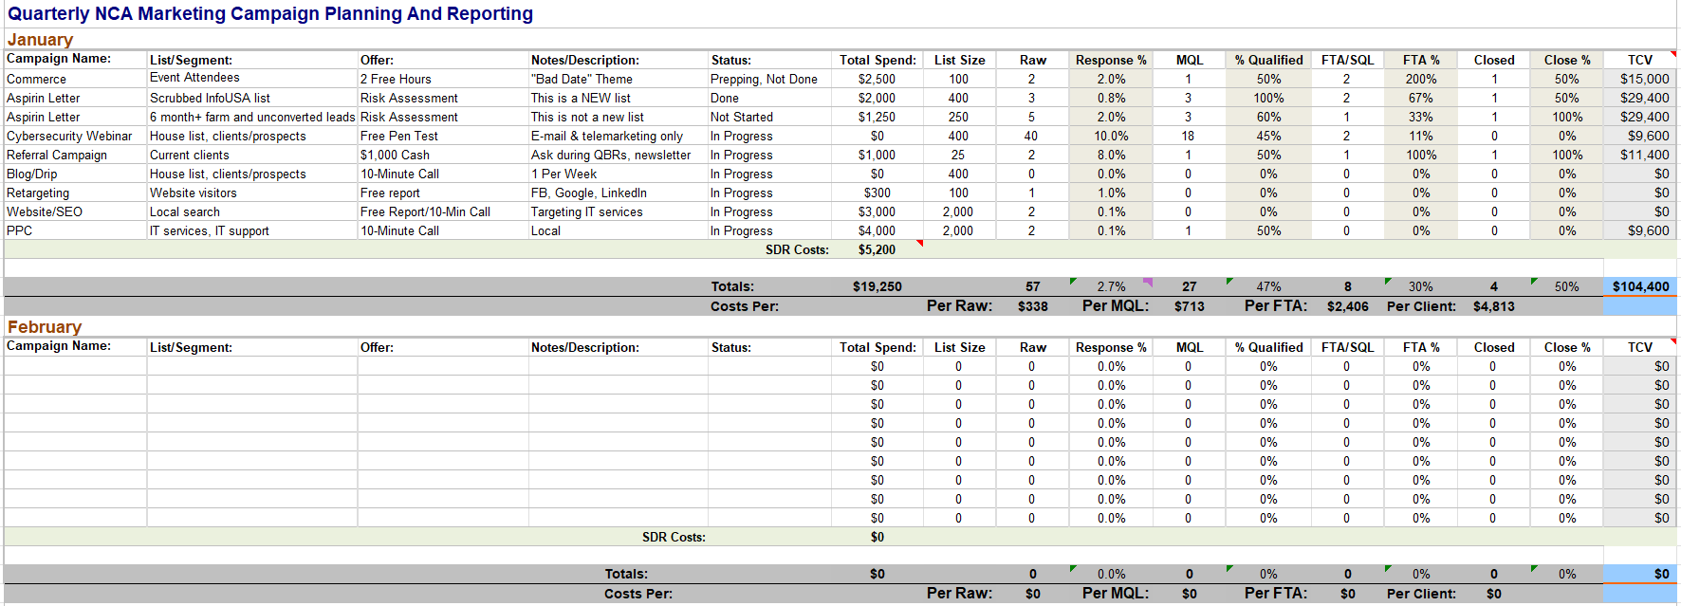

Marketing Campaigns

On the following page is a list of marketing campaigns to drive NCA (new client acquisition). Here are some key things to keep in mind:

- All individual campaigns MUST get the “4 M’s” right:
  - Market: The list or audience you are targeting has to be truly qualified.
  - Message: The message on the campaigns MUST resonate with your target market.
  - Media: Your choices should be driven by what your target market best responds to.
  - Math: You must do backwards planning with reasonable expectations to succeed.
- The more dialed-in and on-point your STRATEGY is, the better all prospecting efforts will be. Similarly, great marketing ASSETS, like a high-converting website, 5-star testimonials and an effective lead generation offer will also make prospecting infinitely more effective.
- You do not have to implement ALL of these tactics to succeed, but you DO have to implement a sufficient number of them to meet the goals you set for MQLs, FTAs and new clients. You might be able to achieve those goals only running a handful of campaigns, or you might need to supplement them from time to time as the economy slows, competition increases, you increase your goals for growth or as campaigns and strategies stop performing.
- Ultimately, the campaigns that will “work” are the ones you’ll actually DO. Half-assed attempts deliver zero results.

NOTE: You must have a membership to our program to access the links to the campaigns outlined. This is a plan we give our clients, so these are posted here for their convenience.

Inexpensive/Easy:
- Repeat any SUCCESSFUL CAMPAIGNS you’ve run in the past.
- Run a REFERRAL campaign to get introductions: https://tmt-link.me/uWvWarSdsfYJ
- With the 9-WORD E-MAIL, go back to recent prospects (under one month old) that “went dark”:
https://tmt-link.me/RVd7eKLzYn9T
- Do the WARM OUTREACH campaign: https://tmt-link.me/Fo4Bf46aZWkF
- Invite all your unconverted leads into a WEBINAR to offer a cyber-assessment, dark web scan or some other appointment-generating offer to reactivate them: https://tmt-link.me/1BXH6eWtVS0N
- Create a new piece of LONG-FORM CONTENT (article, free report, video, etc.) and invite older leads to download it, read it or watch it. Make sure you follow up via phone and e-mail with anyone who downloads it or clicks on the link to view it to see if they’d like to get a “competitive bid” for their IT services business. Remember, we offer many templates. Here’s a session on how to customize a free report template: https://tmt-link.me/TYmOMFFaukaR
- Conduct a 5-AROUND DROP: https://tmt-link.me/zn7QsuER1GtV
- Reach out to JVs, or REFERRAL PARTNERS, to do a webinar or speaking engagement, or to give away some type of lead generation offer: https://tmt-link.me/F29vIFtbr7Pa (Note that you can search “joint venture” on the Dashboard to see a number of additional resources, sessions, case studies and examples of how to use this strategy.)
- Partner with your clients’ INSURANCE AGENT for introductions: https://tmt-link.me/PZfdoV5MHslS
- Find out what NETWORKING groups your clients attend and ask to tag along, even if you have to pay an entry fee. If it’s a membership, most places will allow you to attend the first meeting free so you can decide if it makes sense to join. Here’s a quarterly theme you can do just on networking: https://tmt-link.me/sEsI1inxs8fh
- Initiate a RETARGETING campaign: https://tmt-link.me/FIWmBRZn1I4Q
- Start POSTING great content on social media sites to drive people back to your website, where they can opt in, schedule an appointment and be retargeted. (The Digital Marketing Blueprint is an entire program on digital lead generation: https://tmt-link.me/QgArY1FRDdGB)
- Join and attend NETWORKING EVENTS, particularly those that your clients attend: https://tmt-link.me/sEsI1inxs8fh
- Attend TRADE SHOWS and sponsored events: https://tmt-link.me/X2wwxNVodp8e
- Pick up the phone and start PROSPECTING for new opportunities. Have a good top-of-the-funnel offer to talk about (not just ask if they need IT services). Make 3 to 5 calls and send e-mails in between to follow up, reiterating the offer. The Appointment-Generating Miracle is a program about hiring and managing an SDR, or sales development rep, who can make these calls. There are phone scripts you can use in this program: https://tmt-link.me/vtU1zAb08eKY

More Expensive/Difficult:
- Work on your SEO with articles, Google My Business, local directory listings, etc. This should be ongoing but is a more passive, longer-term strategy (prospecting calls will deliver much faster results): https://tmt-link.me/iu67bC5BeUOu
- Get a client, vendor, friend or other strategic partner to do an ENDORSED MAILING (which can also be an e-mail), or PAY for a “sponsored” e-mail: https://tmt-link.me/lyaDrPIQ7s4g
- Run LinkedIn, Facebook or other PAID DIGITAL ADS: https://tmt-link.me/QgArY1FRDdGB
- Run a “PLANT THE FARM” campaign like Aspirin or the new Closer Look campaign with SDR follow-up: https://tmt-link.me/TM4zFfSCrw9t
- Pay a local association, local meetup or event promoter for an opportunity to PUBLICLY SPEAK at their event (or sell them on having you as a speaker; this is harder but not impossible).
- PAY a local ASSOCIATION to promote your offer, webinar, etc., via e-mail (some offer this as a sponsorship opportunity).
- Start a CANVASSING campaign beyond the 5-Around Drop: https://tmt-link.me/sPs6vECrgE9E and https://tmt-link.me/KyCIXbuQslGN
- Run PPC (Google AdWords, Bing): https://tmt-link.me/AYKN280SGJ07
- Conduct one-on-one LINKEDIN PROSPECTING or run LINKEDIN ADS: https://tmt-link.me/KFriIvvhztJt
- Run radio ads, TV ADS.

Bonus
Material
Define The Psychographics Of Your Target Market:

Once you have the demographics of your target market defined, see if you can accurately answer the following questions about them. If you have more than one “avatar,” such as small business owners for managed services and IT directors at larger organizations for co-managed IT, you need to answer the following questions for EACH:

- Who is the primary decision maker(s)? Who influences their decisions?
- What are the most common situations/events/problems that drive them to seek out your services? How do THEY articulate that situation/event/problem?
- What are their primary goals in their business (if owner) or job (if an employee)? What KPIs are they focused on? What do they think about MOST?
- What keeps them awake at night? What are they afraid of? Anxious about?
- What are the most common frustrations they deal with on a day-to-day basis?
- What do they HATE? WHO do they hate?

- What is their buying criterion for what you sell? How “savvy” of a buyer are they?

- What beliefs or feelings do they have about what you sell?
- What beliefs or feelings do they have about IT services in general? The industry as a whole?
- What other characteristics make them a good prospective client?
- Where do they get their information? What associations do they belong to? What conferences do they attend?

Other Things To Consider
When Selecting A Target Market:

Expertise: Do you have experience in working with your chosen target market? Do you have deep knowledge of their industry and how their business operates?

Future Opportunity: Does this target market (and what you sell them) offer you perpetual opportunity, or is the industry shrinking and/or changing in such a way that would limit your future potential sales?

Testimonial(s): Do you have a FANTASTIC testimonial/case study you can build on from one or more of these types of clients? Having one will make the acquisition of similar clients much easier.
Sufficient Market Size: Are enough of these prospects in your service area (local, regional or national) to support your revenue goals?

Strategic Advantage: Do you have a strategic partner or client that gives you a unique advantage in reaching your chosen target market?
Deeper Comparison Of Industry Verticals/Avatars

As we’ve already discussed, one of the easiest ways to identify profitable market niches is to look within your own client base for solutions and clients you can replicate. However, many IT firms service a wide variety of client types and have ideal, “right fit” clients in more than one vertical, making it difficult to choose. This form will help you evaluate the different types of vertical target markets you service to uncover overlooked opportunities and profitable niches you can capitalize on. Simply choose a client type and rate the opportunity using the questions below. Rate each opportunity on a scale of 1 to 5, with 1 being poor and 5 being ideal or the highest possible positive rating.
- How Easy Is It To Identify Similar Clients? Can you easily obtain a list of prospects (decision makers) for this target market? Are there lists you can rent? Associations? Trade publications? JV partners?
- Can They Easily Afford Your Services? Would a $1,500-per-month managed services contract be a real strain on their resources (1), making it difficult to sell and collect on, or would it be something they can easily pay for (5)? The less strain on their budget, the easier it will be to sell.
- How Profitable? Did the services you deliver have a high profit margin (5 rating) or very little margin (1 rating)? Make sure you know the gross profit and net profit for each solution you sell! There is no point in adding more clients to an unprofitable model, or in attracting unprofitable clients. Remember, if you don’t sell a high-profit service, you will have to make up for it in numbers.
- Are There Ongoing Opportunities? Did the client only want you to implement a one-off solution with no recurring opportunities (1) or is there a constant steady flow of work (5)?
- How Common Is The Problem You Solved? Were the problems/solutions unique to this particular client (1) or were their problems/solutions commonly shared by other businesses in that same niche so that you could easily replicate the solution you’ve provided (5)?
- Are You Solving A Major Problem For That Client? The bigger and more painful the problem, the more a client will pay for the solution. For example, is the “problem” causing them to lose significant revenue opportunities, profits and clients? Are there government regulations or legal requirements driving the need? Competitive pressure? Or is your solution more of a “nice to have” (1) instead of an absolute must (5)?
- How Easy Was It To Sell? Take into consideration how easy (or difficult!) it was to get an appointment with the decision maker, the length of the sales cycle and the number of objections you had to overcome.
- Is There Sufficient Market Size? Is the market big enough to easily sustain the sales/profits you want (5) or are there only a small number where, even if you got 100% of them to buy, you couldn’t sustain your business (1)? NOTE: Another consideration is whether the market is stable and GROWING or shrinking; you don’t want to build on a market niche that is collapsing or becoming obsolete.
- Leverage Point Rating: This includes your expertise, background, experience or the contacts you have within a certain vertical market. For example, you have MORE leverage in a target market if you have worked with multiple companies in that industry and have a deep knowledge of how they operate and what problems they are likely to have. Other high-leverage points include having a good list of prospects/customers in that niche, relationships with good potential JV partners, expertise you might have about a solution they need or custom solutions you’ve developed specific to that industry.
- Total Rating: Add up all the ratings for each client in this column. Those client types with the highest ratings are the ones you want to focus on.

IMPORTANT! There is no such thing as a “perfect” target market! Every niche has pros and cons, as well as its fair share of cheapskates and losers. Remember, it’s YOUR job to make them see value in what you do and to craft a service they will want to buy.

Target Market Scorecard
Target Market #1:
Easy To Identify? | Can They Easily Afford Your Services? | How Profitable? | Ongoing Opportunities? | How Common Is The Problem? | Are You Solving A Major Problem? | How Easy Was It To Sell? | Market Size? | Leverage Point Rating: | Total Rating

Target Market #2:
Easy To Identify? | Can They Easily Afford Your Services? | How Profitable? | Ongoing Opportunities? | How Common Is The Problem? | Are You Solving A Major Problem? | How Easy Was It To Sell? | Market Size? | Leverage Point Rating: | Total Rating

Target Market #3:
Easy To Identify? | Can They Easily Afford Your Services? | How Profitable? | Ongoing Opportunities? | How Common Is The Problem? | Are You Solving A Major Problem? | How Easy Was It To Sell? | Market Size? | Leverage Point Rating: | Total Rating

How To Research Your Target Market:

When researching your market, you’re essentially trying to uncover detailed answers to questions outlined on the following page of this workbook.

- Pay attention during the sales calls you’re already going on. Prospects WILL tell you what they want, why they want it, what they want to avoid and what’s most important to them in making the buying decision – IF YOU ASK AND LISTEN.
- Get out to networking events and talk to them! A handful of meaningful one-on-one conversations with a few prospects about your services is worth far more than pages of research reports and statistics. You can get these interviews simply by going to industry events, joining online forums, visiting or joining peer groups they belong to, getting involved in their industry’s associations, getting people you know or do business with to make introductions or even by cold-call prospecting them!
- Subscribe to and read the top 3 to 5 industry publications and online web portals they subscribe to. (Note: You want to subscribe to get on the mailing list and receive promotions from other vendors selling to the same target market.)
- Talk to other noncompetitive vendors selling to your chosen target market for insights on how they sell to them, hot buttons, frustrations, trends, how they make buying decisions, etc. Just be sure you talk to someone who’s actually successful at selling to them; you don’t want to take advice from a loser!
- Attend every major trade show and event for your niche’s industry – both locally and nationally. You can learn a LOT just by walking around and talking to other vendors, attendees and speakers.
- Use Google’s AdWords tool to research search terms and volume for keywords your target market might use to find you. Is there a high volume? Low volume? Is it competitive?

Additional Questions You Should Know The Answers To About Your Target Market:
- Who is your prospect likely buying from right now or what service/solution do they have in place now that you would replace? Specifically, how are you BETTER?
- What is the current market size available for you to sell to? Is it growing or shrinking?
- Where or how do they start looking (shopping) to buy your services? What is/are the first question(s) they ask themselves when looking to buy your services?
- What are the top 3 to 5 most important factors or criteria they look for when buying what you are selling? Why are those factors or criteria important to them?
- What are the top 3 biggest frustrations they have with dealing with MSPs or IT services companies (you and your competition)? What irritates them?
- How would your ideal target client describe (exact language) their frustrations, problems or dissatisfactions with IT (or whatever it is you solve for them)?
- HOW do they buy your services? What is the decision-making process? Who’s involved?
- What’s the single biggest benefit you deliver to them? What are they REALLY buying?
- Can you make a clear and compelling financial argument as to why they should buy what you’re selling over your competition? Over doing it themselves in-house?
- Do the prospects already buy and/or understand what you sell (commodity end of the spectrum), or do they need to be educated (innovation end of the spectrum)?

  - Innovation
- You need to develop the NEED
- Educating the prospect becomes important
- Discounts aren’t important, but justifying the price IS
- Minimize the “thing” and focus on the RESULTS
- The better you are at describing the problem/pain/situation the prospect is dealing with, the better your results will be
- Lead generation with educational webinars, videos, reports, etc., is critical
  - Commodity
- You don’t need to educate them on why they need to buy it
- Price and convenience become more important
- USP becomes more important (why you over everyone else)
- You can generate sales with one step, regardless of price (new car)
- You can talk more about features since the client will understand them
- What regulatory/government actions are impacting how they do business or WILL impact how they do business?

- What trends are going on in their industry?
- What are the top 3 to 5 events they attend? What are the top 3 to 5 websites they visit or read, or publications they subscribe to?
- Who are the key influential people in their industry who they respect and follow?
- Who are the top 10 to 20 vendors selling other services to them (noncompetitive with what you do)? NOTE: This is your list of JV partners!

- Do they have their own language? What are key acronyms or buzzwords they use?
- Are they web and technology savvy?
- What social media sites do they frequent, if any?
- How do they get paid to do what they do?
- What applications, data or systems are critical to their business?
- What are all the critical applications they use to run their business?
- What’s their average annual revenue? Growth rate?
- What KPIs do they MOST pay attention to?

- What are they angry about or who are they angry with (can be government regulations, trends, other competitors, their clients, etc.)?
- What’s the fastest and easiest inroad (product or service) for you to gain access?

