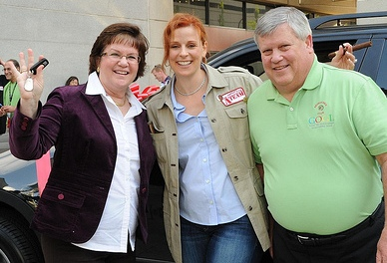
FOR IMMEDIATE RELEASE

IT Business Owners, Brad And Victoria Myers Win A Brand New BMW And The Title Of Spokesperson For Exceptional Growth In Sales And Profits During A Down Economy

Franklin, TN-April 20, 2010 – Technology Marketing Toolkit, Inc. – After months of preparation and some heavy competition, Brad and Victoria Myers of Myers Networks Solutions accepted the keys to a brand new BMW and the distinguished title of “Better Your Best” 2010 contest winner. Robin Robins, President of Technology Marketing Toolkit, Inc., awarded them this prize and the position of Spokesperson during the 2010 Marketing & Money-Making Boot Camp, held April 14-17 in Nashville, Tennessee, for achieving exceptional growth in sales and profits.
Brad and Victoria Myers of California-based, Myers Network Solutions, celebrate their new position as Spokesperson as they are handed the keys to their new BMW by marketing coach, Robin Robins, President of Technology Marketing Toolkit, Inc.

While many folks were scrambling to complete their tax returns on time, over 350 of the nation’s top experts in the IT industry gathered to share best practices and recession-proof marketing strategies for their small businesses. The highlight of this annual seminar was the “Better Your Best” contest which featured members of Robin Robins’ Genius League Coaching Program as they competed for the Spokesperson Position and a new car with show-and-tell marketing strategies they've used to achieve a combined average increase of 149% in net profits, an astounding 1,083% increase in clients on a recurring revenue basis, and a 158% increase in monthly recurring revenue.

“We are so excited about this! This has been a goal of ours for 2 years,” stated a proud Victoria Myers. “We are honored to accept the role of Spokesperson for 2010 and we are super fans of Robin!”

“I have always challenged my clients to think big and create the business and income that others only dream about, regardless of what the economy is doing. In times like these, it takes true leadership and courage to relentlessly pursue growth while everyone else lets fear and excuses hold them back. But Brad and Victoria Myers are perfect examples of how anything is possible; and using the low-cost marketing strategies I have taught them, they and the other candidates have achieved increases in sales and profits that others think are simply impossible,” Robin Robins says. “Choosing the winner of this contest is always a difficult process. Each of the contestants demonstrated tremendous growth and success over the last year. They all deserve recognition for their incredible results.”

About Robin Robins and Technology Marketing Toolkit
Robin Robins is an independent technology marketing consultant, sales trainer, and author that specializes in inexpensive and highly effective marketing strategies for small to medium VARs, Systems Integrators, Managed Services Providers, Solution Providers, and IT consulting firms. She has developed and authored the Technology Marketing Toolkit System which is the definitive guide to marketing technology services. She currently runs the largest sales and marketing coaching program in the world for IT consulting firms and managed services providers. For more information, please visit our website at www.technologymarketingtoolkit.com.

CONTACT:
Robin Robins, President
info@technologymarketingtoolkit.com
615.790.5011

