FOR IMMEDIATE RELEASE
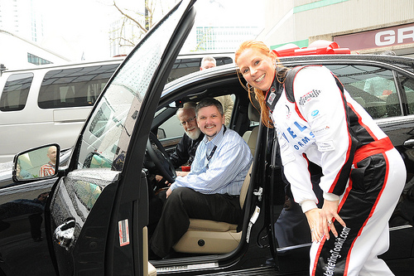
MSPs Rally In Tough Times
Franklin, TN – April 4, 2011 – Technology Marketing Toolkit, Inc. – It’s no secret, times are tough. But despite the new economic environment, there’s a distinct group of IT Business owners who are not only growing their businesses but are actually experiencing drastic increases in net profit, new clients and recurring revenue.
Over 400 of the nation’s top experts in the IT industry recently gathered in Nashville, Tennessee to share best practices and recession-proof marketing strategies for their small businesses. The highlight of this annual seminar was the “Better Your Best” contest, in which members of Robin Robins’ Producers Club Coaching Program competed for a new car and the chance to be Robin Robins’ Spokesperson. The contestants all shared the marketing strategies that they've used to achieve a combined average increase of 356% in net profits, and a combined average increase of 50% in monthly recurring revenue.
Tom Malesic of Pennsylvania-based EZSolution celebrates his new position as Robin Robins’ Spokesperson as he poses in his newly awarded Mercedes alongside his Marketing Manager, Rich Crockett and his marketing coach, Robin Robins, President of Technology Marketing Toolkit, Inc.

After months of preparation, and despite some hefty competition, Tom Malesic of EZSolution, along with his right-hand man, Rich Crocket, accepted the keys to a brand new Mercedes and the distinguished title of “Better Your Best” 2011 contest winner. Robin Robins, President of Technology Marketing Toolkit, Inc., awarded Tom his prize and his new title during the 2011 Marketing & Money-Making Boot Camp, held March 23rd-26th, in recognition of his exceptional growth in sales and profits.
“It’s hard to believe how much Robin has changed my business in only 2 years,” stated an elated Tom Malesic. “She taught me how to create monthly recurring revenue, how to be the expert in my industry and she provided an amazing education on marketing campaigns and strategies. Marketing isn’t just about the individual campaigns. It is the collective marketing efforts that return the big results. Robin has given me opportunities to learn not only about marketing, but also about business. Her program has allowed me to be a better business owner and a better person. I am honored to have won the Mercedes E350 and to be her 2011 spokesperson.”
When asked about her motivation for running this competition, Robin Robins stated, "I love hosting this event every year, and I am honored to have Tom as my new spokesperson, but the true excitement in all of this is knowing that even when times are the toughest they have been in a while, these guys can still produce their greatest successes ever. This is the 4th time we've run this competition and every year the judging gets harder. Every single contestant had great numbers and a great story to tell. The monetary results speak for themselves, but the greatest improvement tends to be in their mindset and overall entrepreneurial strategies – the intangible results that change their businesses and lives forever."
About Robin Robins and Technology Marketing Toolkit
Robin Robins is an independent technology marketing consultant, sales trainer and author who specializes in inexpensive and highly effective marketing strategies for small to medium VARs, Systems Integrators, Managed Services Providers, Solution Providers and IT consulting firms. She has developed and authored the Technology Marketing Toolkit System which is the definitive guide to marketing technology services. She currently runs the largest sales and marketing coaching program in the world for IT consulting firms and managed services providers. For more information, please visit our website at www.technologymarketingtoolkit.com.
CONTACT:
Robin Robins, President
info@technologymarketingtoolkit.com
615.790.5011

